H.T No
Regulations:
A22

Sreenidhi Institute of Science and Technology
(An Autonomous Institution)
Code No:9F303 Date:20- January-2025 (FN)

B.Tech II-Year I- Semester External Examination, January-2025 (Regular & Supplementary)
DISCRETE MATHEMATICS (CSE,IT,CS,AIML,DS & IOT)

Time: 3 Hours Max.Marks:60

Note: a) No additional answer sheets will be provided.
b) All sub-parts of a question must be answered at one place only, otherwise it will not be valued.
c) Missing data can be assumed suitably.
Bloom's Cognitive Levels of Learning (BCLL)

Remember | L1 | Apply | L3 | Evaluate | L5
Understand | L2 | Analyze | L4 | Create | L6

Part - A Max.Marks: 6x2=12

Answer all QUESTIONS, EACH QUESTION CARRIES 2 MARKS.

 |  | BCLL | CO(s) | Marks
1 | Show that the propositions ~(pq) and ~p v ~q are logically equivalent using truth table. | L1 | CO1 | [2M]
2 | Write any two rules of inference in first order logic. | L1 | CO2 | [2M]
3 | Define (i) Reflexive property and (ii) Anti-symmetric property. | L1 | CO3 | [2M]
4 | How many four-digit numbers can be formed using the elements of the set {1,2,3,7,9}. | L2 | CO4 | [2M]
5 | Using substitution method, solve the recurrence relation a_{n} = a_{n-1} + 3^{n}, where a₀ = 1. | L2 | CO5 | [2M]
6 | Write the incidence matrix representation of the following graph.  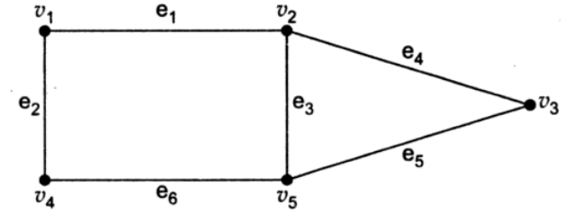 | L2 | CO6 | [2M]

Part – B Max.Marks: 6x8=48
ANSWER ALL QUESTIONS. EACH QUESTION CARRIES 8 MARKS.

 |  | BCLL | CO(s) | Marks
7. | Find the principal conjunctive normal form of the proposition 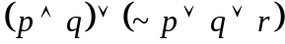 | L2 | CO1 | [8M]
 | OR
8 | a) Prove that, for any propositions p, q, r the compound proposition  {p → (q →r)} → {(p →q) → (p → r)} is a Tautology.  b) Verify the validity of the following argument:  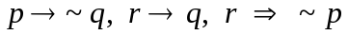 | L2  L3 | CO1 | [8M]
9. | Establish the validity of the following argument: | L3 | CO2 | [8M]
 | OR
10 | Rewrite the following argument using quantifiers, variables and predicate symbols. Prove the validity of the argument. “All healthy people eat an apple a day. Ram does not eat apple a day. Ram is not a healthy person.” | L3 | CO2 | [8M]
11 | Prove that set of fourth roots of unity, G={ 1, -1, i, -i} forms a Group under multiplication. | L3 | CO3 | [8M]
 | OR
12 | Draw the Hasse diagram for the divisibility relation on the sets (i) A ={1, 2, 3, 5, 6, 10, 15, 30} & (ii) B = {1, 2, 3, 4, 6, 12}. | L3 | CO3 | [8M]
13 | a) Find the coefficient of x⁵y⁷ in the expansion of (x + 3y)¹².  b) 51 numbers are chosen from the integers between 1 and 100 inclusively. Prove that 2 of the chosen integers are consecutive. | L3  L3 | CO4 | [8M]
 | OR
14 | a) Find the number of positive integers less than or equal to 2076 and divisible by 3 or 4.  b) Show that if any 20 people are selected then we may choose a subset of 3, so that all 3 were born on the same day of the week. | L3  L3 | CO4 | [8M]
15 | Solve the recurrence relation a_{n} – 5a_{n-1} + 6a_{n-2} = 0, where n ≥ 2, given, a₀ = 1, a₁ = 2 using method of characteristic roots. | L3 | CO5 | [8M]
 | OR
16 | Solve the recurrence relation a_{n+2} – 2a_{n+1} + a_{n} = 2^{n}, n ≥ 0, given, a₀ = 1, a₁ = 2 using the method of generating function. | L3 | CO5 | [8M]
17 | Define Hamiltonian Graph. Find the Hamiltonian cycle of the following graph:  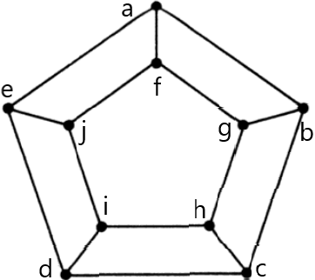 | L4 | CO6 | [8M]
 | OR
18 | Using Breadth first search algorithm and starting with vertex ‘A’, find the spanning tree for the following graph.  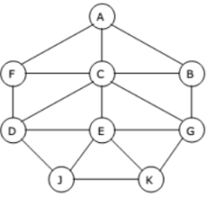 | L4 | CO6 | [8M]

-- 00 -- 00 –

